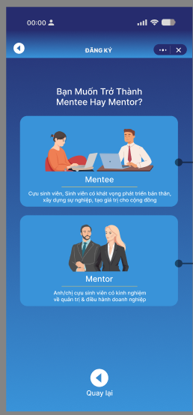

**Gọi Api /auth/register POST**

**{**

**"username": "string",**

**"password": "string",**

**"email": "string",**

**"name": "string",**

**"avt": "string",**

**"gender": true,**

**"company": "string",**

**"field_of_study": "string",**

**"job": "string",**

**"role": "string"**

**}**

**Nếu đăng nhập gọi api /auth/login POST**

**{**

**"username": "string",**

**"password": "string"**

**}**

**Đăng nhập thành công trả về acces_token và refetch_token**

**Api Lấy danh sách Blog GET**

**/blogs**

**{**

**Id:”string”**

**img: “string”**

**summary:“string”**

**create_at: “date”**

**Title: “string”**

**}**

**Api Lấy danh sách Blog detail GET**

**/blog/{id}**

**{**

**Title:”string”**

**img: “string”**

**summary:“string”**

**description:”string”**

**create_at: “date”**

**authorName: “string”**

**}**

**Api danh sách mentor/mentee GET**

**/user?filter=role”mentor”**

***{***

***Id:”string”***

***Name:”string”***

**Avt:”string”**

**field_of_study:”string”**

***}***

**API LẤY CHI tiết người dùng /user/{id}**

**{**

**"email": "string",**

**"name": "string",**

**"avt": "string",**

**dob :”string”**

**"gender": true,**

**"company": "string",**

**"field_of_study": "string",**

**“exp”:”string”**

**}**

**API edit profile /user/{id} PUT**

**{**

**Toàn bộ user Data**

**}**

**Chức năng đặt lịch**

**Api /booking/metor/{id} POST (tạo đơn đặt lịch)**

**{**

**Id: “string”,**

**bookingTitle: “string”,**

**bookingDecrip;”string”**

**schedulingTime: date**

**metee :**

**[**

**{**

**Id: “string”**

**},**

**{**

**Id: “string”**

**},**

**]**

**}**

**Api /booking/metor/detail/{id} GET (Chi tiết đặt lịch)**

**{**

**Id:”string”**

**User :{**

**Id:string**

**Name:string**

**}**

**schedulingTime: date**

**status:””**

**bookingTitle: “string”,**

**bookingDecrip;”string”**

**create_at:date**

**mentee:**

**[**

**{**

**Id:string**

**Name:string**

**}**

**]**

**}**

**Api /booking/history/metor/{id} (Lịch sử đặt lịch)**

**[**

**{**

**Id:””,**

**user : {**

**id:””**

**name:””**

**}**

**schedulingTime: date**

**create_at:”date”**

**status:””**

**}**

**]**